Technical Datasheet Input / Output Modules with MQTT over Ethernet Interface

The IO Module communicates via an Ethernet Interface and is designed to interface seamlessly with other MQTT-compatible devices. The module acts as an input/output device that bridges the MQTT network and the connected gateway, enabling real-time data exchange over the MQTT protocol. This Digital I/O module is robust, energy-efficient, and user-friendly, making it ideal for a wide range of IoT applications. It supports for digital inputs and allows users to easily publish and subscribe to topics on an MQTT broker, facilitating communication with other devices, cloud platforms, and remote monitoring systems.
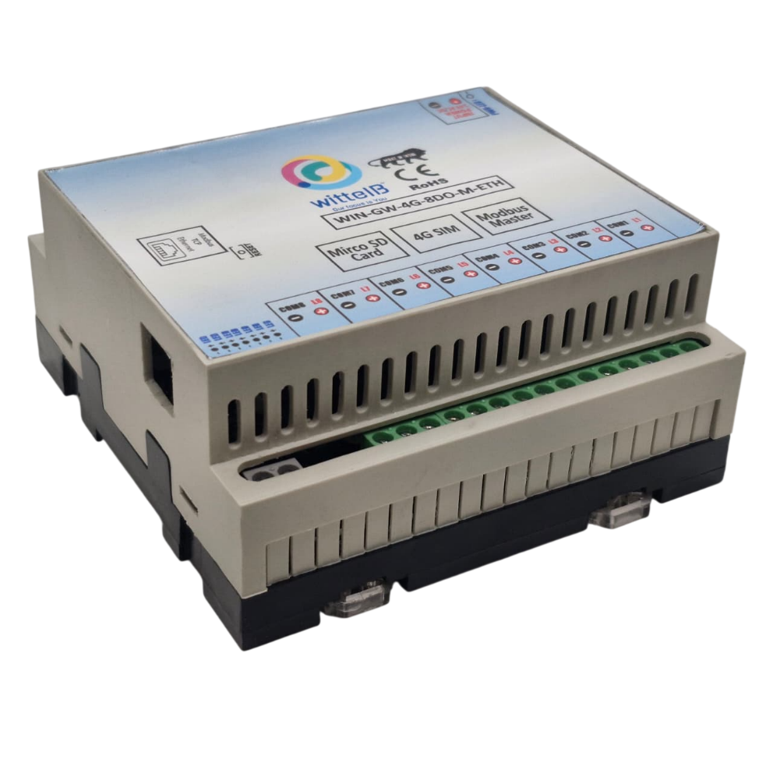
8 Port DO Module with MQTT Over Ethernet: -

The IO modules enclosures are DIN rail Mountable. It’s a closed Enclosure with openings for connectors and LED indicators.
The design of the modules incorporates ‘resettable Fuses’ to safeguard against reverse polarity connection both for Power and Communication port.

Specifications
General –
I/O Connectors 2 Pin 5.08 mm pitch pluggable screw Terminal Block with max 2.5 sq mm wire connection.
Dimensions 110 mm B x 110 mm L x 50 mm H
Power Input Power – 12 – 24 VDC or 24 V AC/DC
Typical – 12V DC @ 500mA
Operating Temperature 0 – 60° C (32 ~ 140°F)
Storage Temperature -20 - 70° C (-4 ~ 158°F)
Storage Humidity 5 ~ 95 % RH, non – Condensing
Certifications 

Relay Output –

Channels 8
Contact Form 1A, 1C
Contact Material Ag Alloy
Contact Capacity 10A @ 240VAC, 10A @ 28VDC
Coil Voltage 5 – 48 VDC
Coil Power 0.36 W
Insulation Resistance 250MΩ
Electrical Life 1 x 10^5
Mechanical Life 1 x 10^7
Operating Time 7 msec, Max 15 msec
Release Time 2 msec, Max 6 msec

Technical Specifications:
- MQTT Protocol Support: Fully compliant with the MQTT protocol, supporting both MQTT 3.1.1 and MQTT 5.0.
- Ethernet Connectivity: Standard Ethernet port (10/100 Mbps) for stable and high-speed data transmission.
- Low Power Consumption: Optimized for low power usage, ideal for battery-operated or energy-efficient applications.
- Easy Integration: Supports standard libraries and tools for easy integration with existing systems.
- Message Retention & Quality of Service (Q o S): Supports various Q o S levels (0, 1, 2) to guarantee message delivery.
- Secure Communication: Support for TLS/SSL encryption for secure communication with MQTT brokers.
- Real-time Data Handling: Efficient, real-time messaging with minimal delay.
- Compact Form Factor: Small and lightweight, designed for embedded systems.

To set up MQTT over Ethernet and find a device's IP address using its MAC address, you'll follow these general steps. This involves setting up an MQTT broker (e.g., Mosquitto, MQTTX, or another broker), connecting devices to the network, and using the MAC address to find the device’s IP. Below is a detailed procedure for setting up MQTT with Ethernet and using a MAC address to find the IP address of a device.

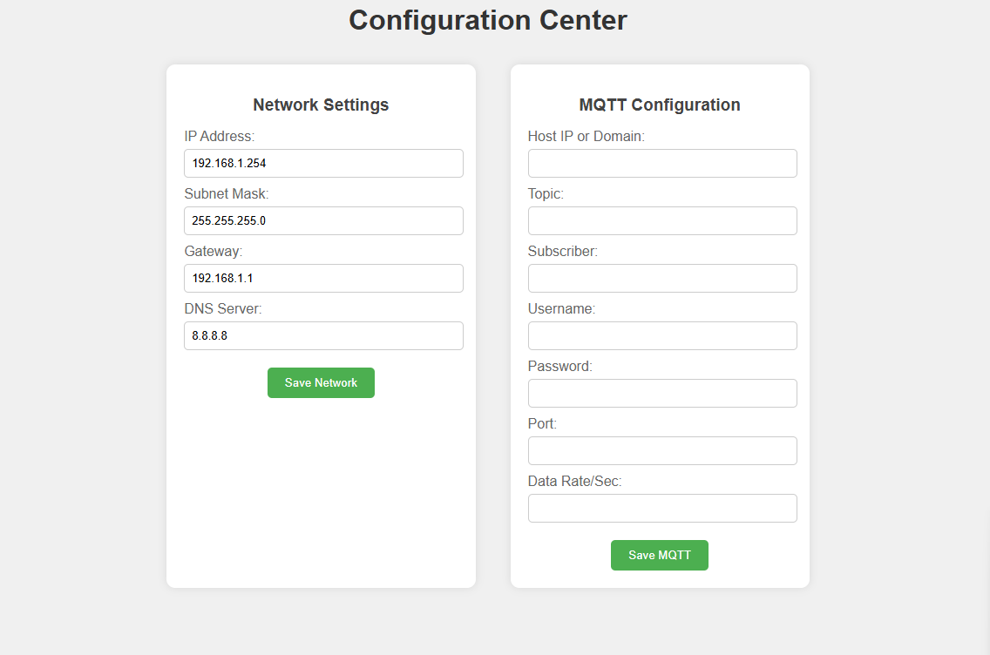
(Image1.1)

Login and MQTT Configuration: -
- Login Prompt
When you open the device's details page, you will be prompted to enter a username and password.
- Default Username
The default username is usually admin.
- Default Password
The default password is typically admin or password.
- MQTT Port
The default MQTT port is 1883 for unencrypted connections.
For secure MQTT over TLS, use port 8883.
- Topic Name
Ensure you configure the correct topic name where the analog and digital data will be published.
For example, if you set the topic to “aitcp”, you will receive analog and digital data on that topic.

- Data Rate
The data rate refers to how often the device publishes messages. You can set it to a specific interval, such as every second or every few seconds, depending on how often you want the data to update.
Note: (Username Password is optional).

- After submitting the data, you will get data on MQTT cloud.

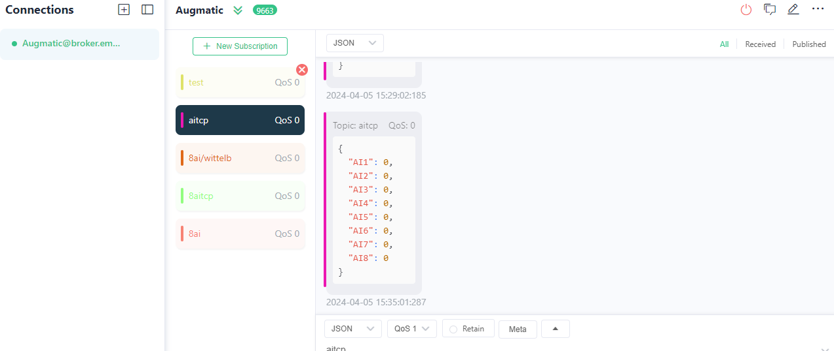
(Image1.2)

- Here you can see the data of digital output data of 8 channel.as shown in image1.2.

DO

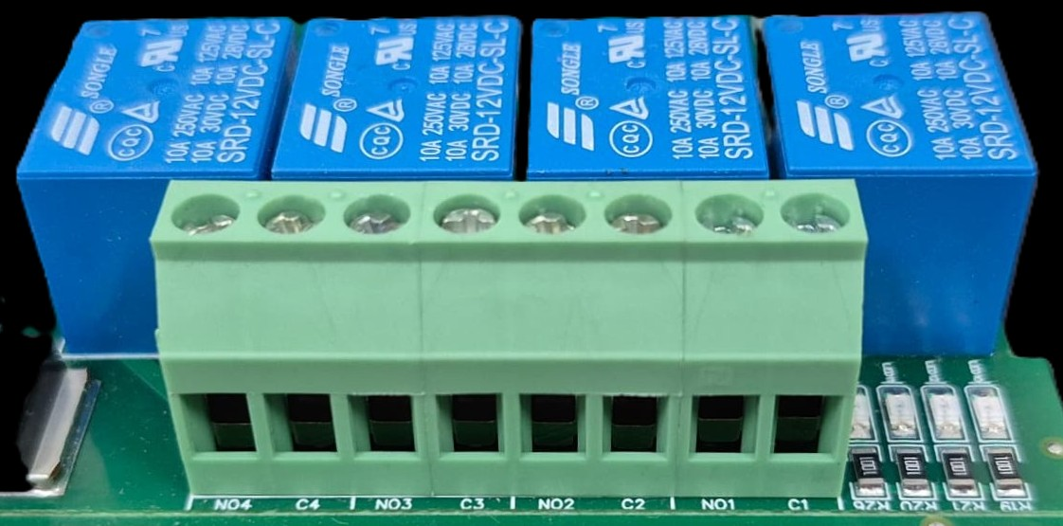





L
O
A
D
N

P
L
O
A
D
N

P
L
O
A
D
N

P
L
O
A
D
N

P

- Digital Output (DO) operation: Each channel provides two terminals: C (Common) and NO (Normally Open). When the relay coil is energized, terminal C is internally connected to NO, allowing current to flow. When the relay is de-energized, the connection between C and NO remains open, and the load stays OFF.
- Load Wiring Connections:
  - AC Load Connection: The AC Live (Phase) wire should be connected to terminal C. The load is connected between terminal NO and Neutral (N).
  - DC Load Connection: The positive supply (+V) should be connected to terminal C. The load is connected between terminal NO and Ground (GND).
- Crucial Safety Recommendation and Rating: It is strongly recommended to switch the Live (Phase) conductor in AC applications to ensure the load is safely de-energized when the relay is off.
Note: Ensure that the connected load does not exceed the relay’s contact rating of 10A @ 250VAC (or 10A @ 125VAC) or 10A @ 30VDC (or 10A @ 28VDC).

Module Details –
I/P Power 24 V DC
DO1 DO2 DO3 DO4

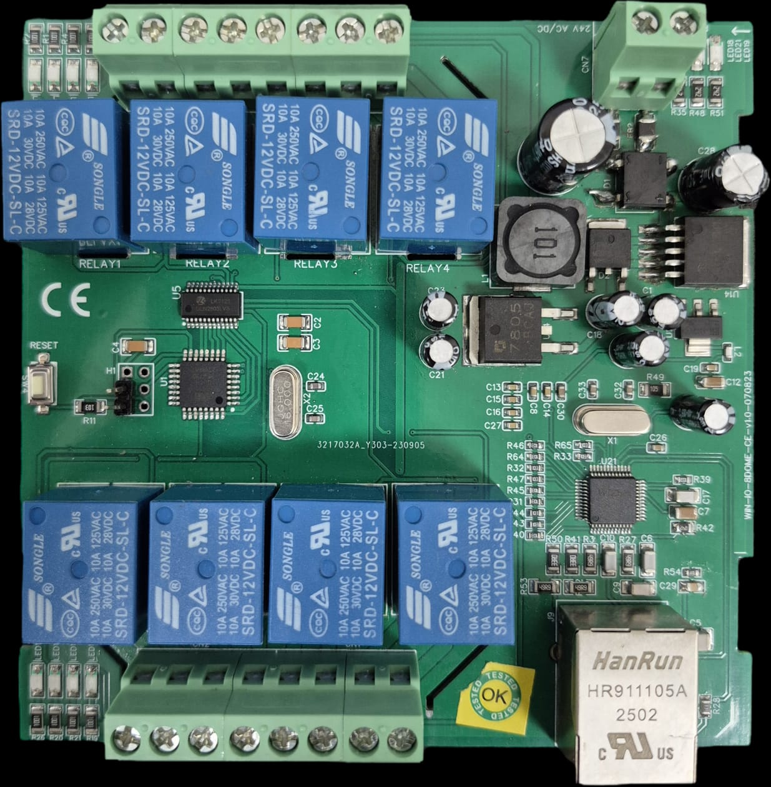
RESET SW
Modbus TCP Port
DO8 DO7 DO6 DO5

Note – Configuration Guide is separately provided for the configuration of the module.

Contact us: -
Augmatic Technologies Pvt. Ltd.,
Plot no 6, Shah Industrial Estate II,
Kotambi,
Vadodara – 391510.
Email – Sales@wittelb.com
Support: support@wittelb.raiseaticket.com / +91 94038 92805

